U8G2 library on the PYNQ-Z2

|  |
| --- |
| Summary:   * U8G2 works with I2C, SPI and parallel interfaces. * Using the I2C hardware library of the PYNQ-Z2 with the U8G2 library * Set up and ready to use for a cheap I2C OLED screen. * Can support a wide range of screens with some modification to the code * **PYNQ-Z2 has no pull up resistors** |

# Revision history

|  |  |  |
| --- | --- | --- |
| Date | Author | Revision |
| 07/02/2024 | Mees Trietsch | Created the document; Described the general organization of the u8g2 library and the combination with the I2C hardware library. |

table of contents

Revision history 1

1 introduction 2

2 The screen 2

3 U8G2 library 2

4 Hardware I2C 2

5 integration 2

6 references 2

# introduction

PYNQ-Z2 contains two I2C outputs, which are connected to the hardware I2C chip of the PS. This document will cover the use of this chip in combination with olikraus’ U8G2 library for driving a cheap OLED screen [1]. The OLED screen is driven by a SH1106 chip which is supported by the U8G2 library. The library supports a range of different screens. For the full list of the supported screen it is recommended to go to the homepage of the U8G2 library. <https://github.com/olikraus/u8g2>

The 3rd and 4th chapter will dive into the working of the U8G2 and hardware I2C library for people who want to build their own code around the U8G2 library. While the 5th chapter will only cover the integration of the hardware I2C into the U8G2 library and how the SH1106_screen library works.

# The screen

The screen is an 1.3 inch OLED screen that has a resolution of 128 by 64 pixels. The screen is powered by either 3V3 or 5V and the IO pins need the same power. The PYNQ-Z2’s logic works on 3V3, so the screen will need to powered with 3V3 to work. The screen also has a good viewing angle of 160 degrees. The PYNQ-Z2 has no pull up resistors but the screen itself does thus the screen is compatible with the PYNQ-Z2. If your screen has no pull up resistors it is necessary to add these.

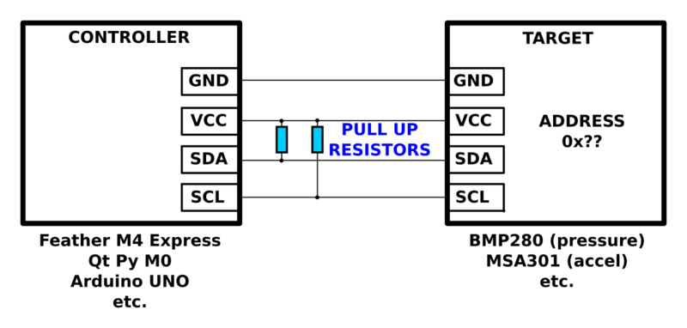

# U8G2 library

The U8G2 library is a library that translates the data that needs to be send to a format that the screen can interpret. The library has a wide range of supported screens and communication protocols. It supports I2C, SPI and parallel interfaces and is widely used with Arduinos, but is also has support for C platforms. However, the library needs to be altered a bit to port it to the new MCU platform. This, and the setup procedure, is further explained in chapter 5

# Hardware I2C

The PYNQ-Z2 has a hardware I2C chip that can be used to interface with devices. This HW I2C chip can be used by the PS by connecting the I2C bus of the PS with the I2C pins on the board as is shown in the following figure. The .xsa file is the bitstream of this block design and can be used to test the screen. By enabling and connecting the I2C bus, the xiicps library is enabled, meaning that the I2C code can be written. The following code enables the I2C chip.

// Look up the config of the IIC

Config = XIicPs_LookupConfig(XPAR_XIICPS_0_DEVICE_ID);

if (NULL == Config) {

printf("XIicPs_LookupConfig failure\r\n");

return XST_FAILURE;

}

// Initialize the IIC using the config

Int status = XIicPs_CfgInitialize(&Iic, Config, Config->BaseAddress);

if (status != XST_SUCCESS) {

printf("XIicPs_CfgInitialize failure\r\n");

return XST_FAILURE;

}

// Do a selftest on the IIC struct to ensure it is working

status = XIicPs_SelfTest(&Iic);

if (status!= XST_SUCCESS) {

printf("IIC selftest FAILED \r\n");

return XST_FAILURE;

}

// Set the clock speed of the IIC bus

status = XIicPs_SetSClk(&Iic, IIC_SCLK_RATE)

if (status != XST_SUCCESS) {

printf("IIC setClock FAILED \r\n");

return XST_FAILURE;

}

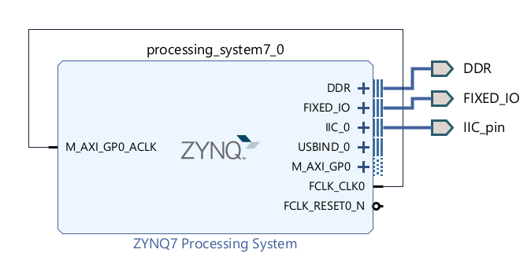

# Porting to new MCU

This chapter covers every that needs to be known to port the U8G2 library to a different c MCU

# Initializing display

# Using different screens

# references